Special relativity: The twin paradox
Name
E-mail
School Technical University of Cluj-Napoca – Computer Science – E_30414

Abstract. This paper shows that the so called "Twin Paradox" of Special Relativity, is in fact not a paradox at all, and is easily resolvable using the Relativistic Domain mathematical formulation of the Special Theory. In physics, the twin paradox is a thought experiment in special relativity involving identical twins, one of whom makes a journey into space in a high-speed rocket and returns home to find that the twin who remained on Earth has aged more.

- Introduction

The twin paradox is the best known thought experiment associated with Einstein’s theory of relativity. An astronaut who makes a journey into space in a high-speed rocket will return home to find he has aged less than a twin who stayed on Earth. This result appears puzzling, since the situation seems symmetrical, as the homebody twin can be considered to have done the traveling with respect to the traveler . Hence it is called a “paradox”. In fact, there is no contradiction and the apparent paradox has a simple resolution in Special Relativity with infinite flat space.

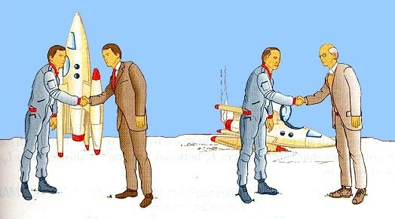
Figure 1.1 When the space traveler twin returns on Earth, he is younger than his brother

2. The Twin Paradox Resolution

In the ensuing analysis, each twin assumes the role of observer of the other in their separate frames of reference. Thus the stationary twin is designated observer O_{S}, while the traveling twin, observer O_{T}.

2.1 The Existence Velocity of Both Twins in Pseudo-Euclidean Space-Time
The Existence Velocity, as defined in [3], of each twin in the reference frame of O_{S} is shown
below in Fig. 2.1.

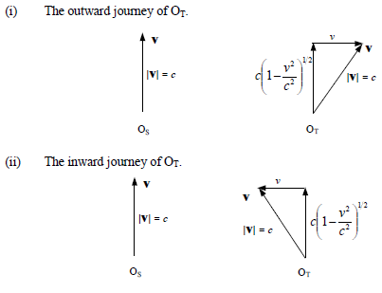
Figure 2.1 The Existence Velocities of O_{S} and O_{T} in Pseudo-Euclidean Space-Time.

2.2 Assessment of the Spatial Velocity of Each Twin by the Other
It is important that each observer correctly determines the spatial velocity of the other in his own frame of reference.

(i) The average spatial velocity of O_{T} as determined by O_{S} is simply

Outward journey
$\frac{dx}{dt}=v$ (2.1)

Inward journey
$\frac{dx}{dt}=-v$ (2.2)

(ii) The average spatial velocity of O_{S} as determined by O_{T} is, using the Lorentz transformations between reference frames.

Outward journey
$dx^{'}=\frac{dx-Vdt}{{\left(1-\frac{V^{2}}{c^{2}}\right)}^{\frac{1}{2}}}=\frac{-Vdt}{{\left(1-\frac{V^{2}}{c^{2}}\right)}^{\frac{1}{2}}}$ (2.3)
$dt^{'}=\frac{dt-dx\frac{V}{c^{2}}}{{\left(1-\frac{V^{2}}{c^{2}}\right)}^{\frac{1}{2}}}=\frac{dt}{{\left(1-\frac{V^{2}}{c^{2}}\right)}^{\frac{1}{2}}}$ (2.4)
and therefore
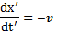 $\frac{dx^{'}}{dt^{'}}=-v$ (2.5)

Inward journey
$dx^{'}=\frac{dx+Vdt}{{\left(1-\frac{V^{2}}{c^{2}}\right)}^{\frac{1}{2}}}=\frac{Vdt}{{\left(1-\frac{V^{2}}{c^{2}}\right)}^{\frac{1}{2}}}$ (2.6)

$dt^{'}=\frac{dt+dx\frac{V}{c^{2}}}{{\left(1-\frac{V^{2}}{c^{2}}\right)}^{\frac{1}{2}}}=\frac{dt}{{\left(1-\frac{V^{2}}{c^{2}}\right)}^{\frac{1}{2}}}$ (2.7)
and therefore
$\frac{dx^{'}}{dt^{'}}=+v$ (2.8)

Hence each twin correctly assesses the spatial velocity magnitude of the other. It is important to note that (2.4) and (2.7) is a measure of the length of a unit of time in the reference frame of O_{T}, and not the journey travel time.

2.3 Assessment of Travel Time (Age Difference)
Because this is only a thought experiment, the assessment of the temporal component of Existence Velocity of each twin by the other, may be incorporated as a realizable measurement.

(i) The travel time of O_{T} as determined by O_{S}.

The travel time of the round trip as measured by OS is Δt. The temporal velocity of O_{T}, for both outward and inward journeys is, from Fig. 2.1 given by

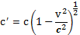 $c^{'}=c{\left(1-\frac{V^{2}}{c^{2}}\right)}^{\frac{1}{2}}$ (2.9)

Therefore the temporal distance travelled by O_{T}, as determined by O_{S} is

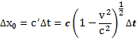 $Δx_{0}=c^{'}Δt=c{\left(1-\frac{V^{2}}{c^{2}}\right)}^{\frac{1}{2}}Δt$ (2.10)

and consequently, the amount of time that has passed for O_{T} as assessed by O_{S} is
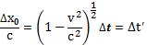 $\frac{Δx_{0}}{c}={\left(1-\frac{V^{2}}{c^{2}}\right)}^{\frac{1}{2}}Δt=Δt^{'}$ (2.11)

(ii) The travel time of O_{S} as determined by O_{T}.

The time of the round trip as measured by OT is given by (2.11), i.e. Δt’. The temporal velocity of O_{S} as measured by O_{T} is

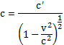 $c=\frac{c^{'}}{{\left(1-\frac{V^{2}}{c^{2}}\right)}^{\frac{1}{2}}}$ . (2.12)

Thus the temporal distance travelled by O_{S}, as determined by O_{T} is

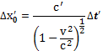 $Δ{x'}_{0}=\frac{c^{'}}{{\left(1-\frac{V^{2}}{c^{2}}\right)}^{\frac{1}{2}}} Δt'$ . (2.13)
and therefore the amount of time that has passed for O_{S} as assessed by O_{T} is from (2.9) and (2.13)

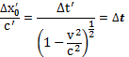 $\frac{Δx_{0}^{'}}{c^{'}}=\frac{Δt^{'}}{{\left(1-\frac{V^{2}}{c^{2}}\right)}^{\frac{1}{2}}}= Δt$ . (2.14)

Therefore, by (2.11), O_{S} assesses that O_{T} has aged less than himself by the amount (Δt -Δt’), and conversely, by (2.13), O_{T} assesses that O_{S} has aged more than himself by the same amount.

3. Assessment of Symmetry

The degree of symmetry between the reference frames of O_{S} and O_{T} can be determined from the above results as follows.

(i) Spatial Distance

(a) The distance moved by O_{S} in his own frame of reference is zero.
(b) The distance moved by O_{T}, as assessed by O_{S}, using a unit measuring rod (all
measurements taken with the rod stationary) is D.
(c) The distance moved by O_{T} in his own frame of reference is zero.
(d) The apparent distance moved by O_{S}, as assessed by O_{T} using a unit measuring
Rod (all measurements taken with the rod moving with a velocity in Pseudo-
Euclidean space of v), 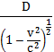 $\frac{D}{{\left(1-\frac{V^{2}}{c^{2}}\right)}^{\frac{1}{2}}}$ . by virtue of the Lorentz-Fitzgerald contraction of the measuring rod.

(b) and (d) show that the spatial dimensions of the two reference frames are not symmetric.

(ii) Temporal Distance

(a) The temporal distance travelled by O_{S} in his own frame of reference is cΔt.
(b) The temporal distance travelled by O_{T}, as measured by O_{S} is given by (2.10),
i.e. 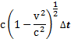 $c{\left(1-\frac{V^{2}}{c^{2}}\right)}^{\frac{1}{2}}Δt$ .
(c) The temporal distance travelled by O_{S} as measured by O_{T} is given by (2.13)
and is, with (2.9) and (2.11) incorporated, $c{\left(1-\frac{V^{2}}{c^{2}}\right)}^{\frac{1}{2}}Δt$ .
(d) The temporal distance moved by O_{T} as measured in his own frame of
reference is 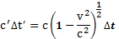 $c'Δt'=c{\left(1-\frac{V^{2}}{c^{2}}\right)}^{\frac{1}{2}}Δt$ .

These results show that the temporal dimensions of the two reference frames are not symmetric. This non-symmetry of distance between the two reference frames is the result of the rotation of the Existence Velocity vector of O_{T}.

(iii) Time

The passage of time is not a symmetric parameter between the two reference frames as exemplified by the time dilatation effect, and confirmed by the results of this analysis, albeit each twin can correctly identify the age difference.

(iv) Velocity

Section 2.1 shows that spatial velocities in the two reference frames are symmetric (in this case diametrically symmetric, same magnitude, different directions). Hence the velocity of light is the same in both frames. This symmetry arises because the non-symmetry of spatial distance is offset by the non-symmetry in time.
The temporal velocities of O_{S} and O_{T} are c and $c{\left(1-\frac{V^{2}}{c^{2}}\right)}^{\frac{1}{2}}$ respectively and therefore not symmetric. This non-symmetry exists because the non-symmetries in temporal distance and time are concurrent as shown by (ii)(d) above.

4. Conclusions

The use of the Relativistic Domain mathematical formulation of the Special Theory , has enabled this paper to easily show that the "Twin Paradox" is in fact not a paradoxical problem at all, as each twin can correctly assess the age difference as a result of the journey of one of them. Albeit this has been achieved by allowing each observer to assess the temporal velocity of the other, a measurement not practicable in real world problems, and only permitted here because of the nature of the experiment.

The age difference correctly identified by each twin is essentially the result of the non-symmetry
of temporal velocity, while importantly, the velocity of light is the same in both reference frames because of the symmetry of spatial velocity between them. Also, it is noted that the analysis here does not require the necessity of considering the acceleration involved in the motion, nor the effect of gravity.

Finally, it has also been shown that the nature of symmetry between the two reference frames is not just a simple overall one, but depends upon the dimensions contained therein and the parameter involved.

References

[1] NPA, Twin Paradox Report, Online. http://twinparadox.net/
[2] Wikipedia, Twin Paradox, Online. https://en.wikipedia.org/wiki/Twin_paradox
[3] P.G.Bass, The Special Theory of Relativity - A Classical Approach, www.relativitydomains.com.
[4] http://motls.blogspot.ro/2007/02/resolving-einsteins-twin-paradox.html.
[5] http://newt.phys.unsw.edu.au/einsteinlight/jw/module4_twin_paradox.htm
[6] https://www.youtube.com/watch?v=ERgwVm9qWKA

